<https://www.greenpeace.org/usa/global-warming/issues/fracking/environmental-impacts-water/>

**Fracking’s Environmental Impacts: Water**

The hydraulic fracturing process poses multiple threats to water supplies.

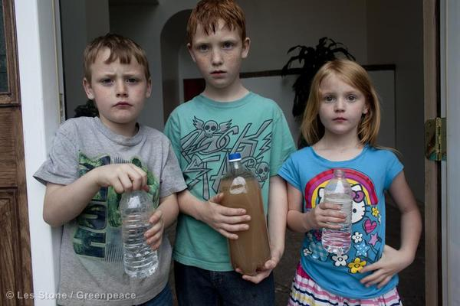

Jessica, Justin, and Joshua Ely hold bottles of water at their house in Dimock. The one at center, is contaminated water from their tap.

© Les Stone / Greenpeace

In order to frack, an enormous amount of water is mixed with various toxic chemical compounds to create frack fluid. This frack fluid is further contaminated by the heavy metals and radioactive elements that exist naturally in the shale. A significant portion of the frack fluid returns to the surface, where it can spill or be dumped into rivers and streams. Underground water supplies can also be contaminated by fracking, through migration of gas and frack fluid underground.

**Water Use**

In order to hydraulically fracture shale and extract the hydrocarbons, large quantities of water and chemicals must be injected underground. Thus [fracking](http://greenpeaceblogs.org/2014/05/28/north-carolina-fracking-bills-sponsor-close-ties-oil-gas-industry/) can pose a threat to local water resources, especially in areas where water is already scarce like the Barnett shale in Texas. In the Marcellus Shale region, the most expansive shale play in the United States, 2 to 10 million gallons of water are needed every time a well is fractured. Because wells can be fractured multiple times, the total amount of water used for fracking is unknown and can vary by location and technology. In western states like [Texas](http://www.rrc.state.tx.us/commissioners/porter/press/012612.php) and Colorado, over 3.6 million gallons are needed per fracture. In 2010, the U.S. EPA estimated that 70 to 140 billion gallons of water were used to fracture just 35,000 wells in the United States, more than was used by the city of [Denver, Colorado](http://www.denverwater.org/AboutUs/KeyFacts/) in the same time period. As of 2012, the fracking industry has drilled around [1.2 million wells](http://www.rollingstone.com/politics/news/the-big-fracking-bubble-the-scam-behind-the-gas-boom-20120301), and is slated to add at least 35,000 new wells every year. (Jeff Goodell, [“The Big Fracking Bubble: The Scam Behind the Gas Boom,”](http://www.rollingstone.com/politics/news/the-big-fracking-bubble-the-scam-behind-the-gas-boom-20120301) Rolling Stone 3/12/12 )

Because of the cost to truck water in from further away, companies prefer to use water from sources as close to the well as possible, which can result in significant impacts on local waterways and overburden local water treatment facilities. In Texas, which is suffering dangerous drought conditions, [fracking continues](http://www.nytimes.com/2011/03/02/us/02gas.html?_r=1) even as water use by citizens is restricted, the landscape wilts and the animal life dies. In 2011 the Wall Street Journal reported that the diversion of water for fracking oil and gas wells is also a[serious threat](http://online.wsj.com/article/SB10001424052970204528204577009930222847246.html) to ranchers and other businesses in Texas. (Russell Gold and Ana Campoy, [“Oil’s Growing Thirst for Water,”](http://online.wsj.com/article/SB10001424052970204528204577009930222847246.html) Wall Street Journal, 12/6/2011)

**Storage Impacts**

**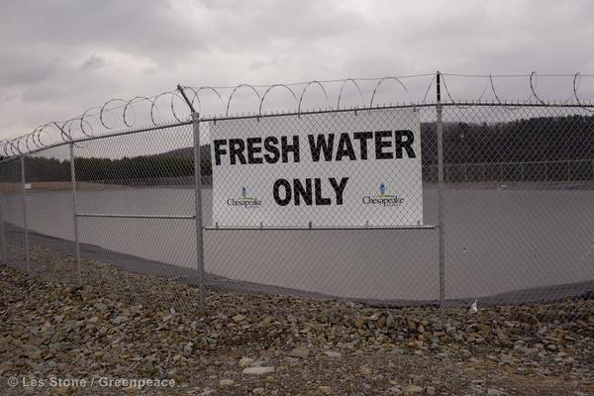**

Because of the tremendous amount of water needed for hydraulic fracturing, fresh water must be acquired, transported, and stored for every well pad.  To manage the massive amounts of water necessary for the hydraulic fracturing process, drillers build large open air pits called impoundments next to the well pads, to store the water before it is used and after it returns to the surface.

There are two types of impoundments, those that hold drilling waste, used while drilling the well bore, and impoundments for the fracking fluid. The frack fluid pits are larger and contain [toxic fracking fluid](http://www.nytimes.com/2011/11/20/magazine/fracking-amwell-township.html?pagewanted=all.).  These open pits have been linked to animal deaths and health effects in humans.  
In Texas, which has few laws regarding wastewater disposal, there is [no requirement](http://marcellus-wv.com/impacts/pits) to line the pits to prevent seepage.

**Fracking Fluids: A Toxic Brew**

**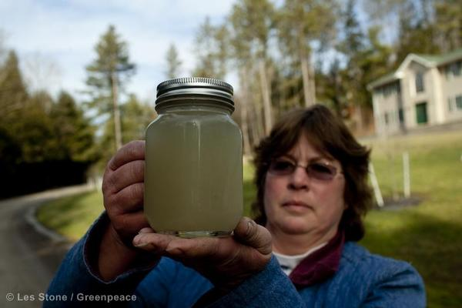**

During the hydraulic fracturing of a well, water is mixed with various chemicals to make a toxic brew called frack fluid. Until recently, neither the federal nor state governments required drilling companies to disclose the ingredients used in frack fluids. Some states have begun to require that companies disclose the chemicals they use, but even in such cases, companies can withhold some chemical names under trade secret exemptions. As a result, a comprehensive list of chemicals used in the fracking process does not exist. Some states have begun to require that companies disclose the chemicals they use, but even in such cases, confidential business information claims result in only partial disclosures. Corporations involved in fracking, like ExxonMobil, have inserted [loopholes](http://www.propublica.org/article/alec-and-exxonmobil-push-loopholes-in-fracking-chemical-disclosure-rules) in drilling legislation that allow them to keep various chemicals used in the fracking process secret.

Some companies have disclosed the contents of their frack fluid in response to community concerns and congressional pressure.  In April 2011, an industry group known as the Interstate Oil and Gas Compact Commission launched [www.fracfocus.org](http://fracfocus.org/), a web-based disclosure database for wells drilled after 2010.  In addition, a Congressional investigation found that between 2005 and 2009 oil and gas service companies used 29 different chemicals in their fracking fluid known to cause cancer or other health risks. (House Energy and Commerce Committee, “Chemicals Used in Hydraulic Fracturing,” April, 2011)

Gas companies routinely claim that frack fluid is harmless because the concentration of chemical additives is low, about two percent.  But just 2% of the billions of gallons of frack fluid created by gas drillers measures up to the use of hundreds of tons of toxic chemicals.  A 2011 [report to Congress](http://www.conservation.ca.gov/dog/general_information/Documents/Hydraulic%20Fracturing%20Report%204%2018%2011.pdf) estimated that from 2005 to 2009, 14 leading fracking companies used (before mixing with water) 780 million gallons of 750 different chemicals. (House Energy and Commerce Committee, Minority Staff Report, “Chemicals Used in Hydraulic Fracturing,” April, 2011)

Drilling wastewater is so poisonous, when a gas company that legally doused a patch of West Virginia forest with salty wastewater from a drilling operation, it [killed ground vegetation](http://theintelligencer.net/page/content.detail/id/141785/W-Va--study-raises-questions-about-fracking-fluid-.html?isap=1&nav=535) within days and more than half the trees within two years. Wastewater from fracking has also been linked to livestock and [family pet deaths](http://www.examiner.com/article/studies-find-california-fracking-wells-may-kill-livestock-family-pets) across the country.

Moreover, many [chemicals](http://www.ewg.org/drillingaroundthelaw) used in fracking have been documented to have deleterious health effects at [small levels](http://insideclimatenews.org/news/20120321/endocrine-disrupting-chemicals-fracking-natural-gas-low-dose-environmental-health) of exposure.

Some of the chemicals that comprise frack fluid are highly toxic and cancer causing, like Benzene, Toluene, 2-butoxyethanol (a main ingredient to anti-freeze and oil dispersants), and heavy metals.[The Endocrine Disruptor Exchange](http://www.endocrinedisruption.com/home.php) (TEDX) identified 353 chemicals used in fracking, many of which can [cause cancer](http://www.endocrinedisruption.com/chemicals.journalarticle.php) and other serious health, even in small doses.

Once the frack fluid mixture is injected into the ground it can also pick up or entrain further contaminants, like radium, a cancer-causing radioactive particle found deep within the Marcellus and other shales.  Radium has a half life of over 1,000 years and is produced from Uranium, which has a much longer half life.  Because Radium is water soluble, all frack fluid used in the [Marcellus Shale](http://www.epa.gov/region3/marcellus_shale/#wastewater)becomes radioactive to some degree.

**Contamination of Water Wells and Gas Migration**

One of the gravest threats posed by fracking is the contamination of drinking water wells, vital sources of water for many rural communities.  Though the industry has attempted to obscure evidence of well water contamination by fracking, multiple instances have come to light.

* In Pennsylvania, Colorado, Ohio and Wyoming, fracking has been linked to drinking water contamination and property damage. (See [Propublica’s series of reports](http://www.propublica.org/series/fracking" \t "_blank) on fracking)
* A [Duke study](http://www.nicholas.duke.edu/cgc/pnas2011.pdf) examining 60 sites in New York and Pennsylvania found “systematic evidence for methane contamination” in household drinking water.  Water wells half a mile from drilling operations were contaminated by methane at 17 times the rate of those farther from gas developments. Although methane in water has not been studied closely as a health hazard, it can seep into houses and build up to explosive levels.
* In December 2011, US EPA released a [121-page draft report](http://yosemite.epa.gov/opa/admpress.nsf/d0cf6618525a9efb85257359003fb69d/ef35bd26a80d6ce3852579600065c94e!OpenDocument&Highlight=2,Pavillion) linking the contamination of drinking water wells near the town of Pavillion, Wyoming to nearby [gas drilling](http://www.propublica.org/article/feds-link-water-contamination-to-fracking-for-first-time).
* An investigation by [ProPublica](http://www.propublica.org/article/so-is-dimocks-water-really-safe-to-drink) found that years after their wells were contaminated by nearby fracking operations, EPA began to [supply water to residents](http://www.propublica.org/article/years-after-evidence-of-fracking-contamination-epa-to-supply-drinking-water) of Dimock, Pennsylvania.
* In New York, claims have already been filed against the Anschutz Exploration Corporation and its subcontractors on behalf of nine families for the [contamination of their drinking water](http://www.prnewswire.com/news-releases/first-claim-filed-in-new-york-for-contamination-caused-by-natural-gas-drilling-116174439.html)due to natural gas exploration and drilling.
* A scene in “[Gasland](http://www.gaslandthemovie.com/" \t "_blank),” a documentary in which a homeowner was able to light the water flowing out of his kitchen tap, made many people aware of the dangers of fracking. [Scientific American](http://www.scientificamerican.com/article.cfm?id=natural-gas-make-water-burn) also published a ProPublica investigation that found “a string of documented cases of gas escaping into drinking water – in Pennsylvania and other states.”
* A 1987 report concluded that hydraulic fracturing fluids or gel used by the Kaiser Exploration and Mining Company [contaminated a well](http://www.nytimes.com/2011/08/04/us/04natgas.html?_r=1) roughly 600 feet away on the property of James Parsons in Jackson County, W.Va.

In spite of the evidence, the oil and gas industry routinely claims that fracking has never resulted in water contamination.

**How Fracking Contaminates**

Groundwater becomes contaminated by hydraulic fracturing in a number of ways, including leakage from liquid storage areas, leakage from injection wells, leakage during hydrofracking along faults or up abandoned wells, seepage into the ground when wastewater and residuals are applied to land (i.e. used for irrigation or on roads for dust suppression or de-icing), and other means. (US EPA, Science Advisory Board, Hydraulic Fracturing Review Panel, report to Lisa P. Jackson, August 4, 2011).

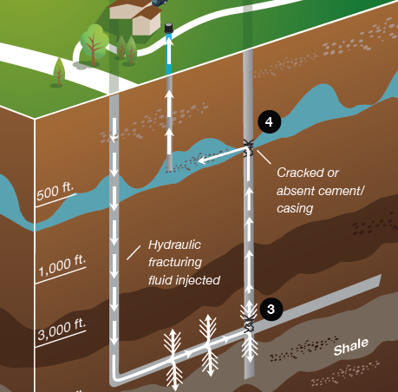

The cement casing which rings the well bore and goes through underground aquifers is meant to act as a barrier between underground water and the shaft through which frack fluid and gas flow.  But the casing can fail or break during the fracturing process, allowing the frack fluid or naturally-occurring contaminants to contaminate groundwater.  When that happens, frack fluid and methane can leak from the well bore directly into the water supply, causing dangerous gas buildups, and making water unfit to drink. (Abrahm Lustgarten and ProPublica, “[Drill for Natural Gas, Pollute Water](https://www.greenpeace.org/usa/Templates/Planet3/Pages/11/17/2008%20http:/www.scientificamerican.com/article.cfm?id=drill-for-natural-gas-pollute-water),” Scientific American, 11/17/2008)

Even if the cement casings hold, gas can travel up from the shale layer to the water table. When gas travels through fractures in the rock layer above the shale and in to water supplies, it is called gas migration.  (Abrahm Lustgarten and ProPublica, “[Does Natural Gas Make Water Burn](http://www.scientificamerican.com/article.cfm?id=natural-gas-make-water-burn)?” Scientific American, 4/27/09)

It is common for wells to lose pressure during the fracking stage, which indicates that the[frack fluid is not contained](http://www.pittsburghgeologicalsociety.org/naturalgas.pdf) within the well and is seeping into some place the drillers did not anticipate.  There has not been enough study of this phenomenon, even though drillers indicate it happens on a frequent basis.

**Frack Fluid Disposal**

Disposal of the toxic and sometimes radioactive frack fluid is a major logistical problem for fracking companies.  When a well is hydraulically fractured, somewhere between 18 and 80 percent of the frack fluid injected into the well will return to the surface.  This water, called “flowback” is heavily contaminated by the chemical mixtures that comprise the frack fluid, as well as dissolved salts and heavy metals from deep within the earth.  Estimates from the industry indicate that drillers in Pennsylvania created approximately 19 million gallons of this wastewater per day in 2011. The Susquehanna River Basin Commission estimates 20 million gallons per day (MGD) for that same timeframe. ([“Permitting Strategy for High Total Dissolved Solids Wastewater Discharges,”](http://www.reuters.com/article/2009/04/15/idUS213361+15-Apr-2009+PRN20090415)4/11/2009)  
There is currently[no comprehensive set of national standards](http://articles.philly.com/2011-10-21/business/30305478_1_shale-gas-drilling-wastewater-marcellus-shale-coalition) for the disposal of fracking wastewater.  
(see “Halliburton Loophole”).

The presence of certain contaminants commonly found in fracking wastewater — including bromide (which can create toxic by-products) and radionuclides, as well as Total Dissolved Solids (TDS) like salts (for which conventional wastewater treatment is largely ineffective) — are of major concern not only because of the potential impacts on rivers, streams and groundwater, but also for downstream water treatment plants, where conventional treatment technologies are not equipped to deal with such contaminants.  According to US EPA, “only a limited number of Publicly Owned Treatment Plants (POTWs) have the ancillary treatment technologies needed to remove the constituents in hydraulic fracturing return waters.” (US EPA, Science Advisory Board, Hydraulic Fracturing Review Panel, report to Lisa P. Jackson, August 4, 2011).

Because of lax regulation, fracking companies commonly dispose of contaminated fracking water in the cheapest, easiest ways they can find, regardless of the consequences for communities, water treatment facilities, and the environment.  This has led to abuses of waterways and communities close to frack sites.

The New York Times reported that in Pennsylvania, wastewater contaminated with radium and other carcinogens was dumped upstream from the intake pipe of a drinking water plant. (Ian Urbina,[“Regulation Lax as Gas Wells’ Tainted Water Hits Rivers,”](http://www.nytimes.com/2011/02/27/us/27gas.html?pagewanted=all) New York Times, 2/26/2011)

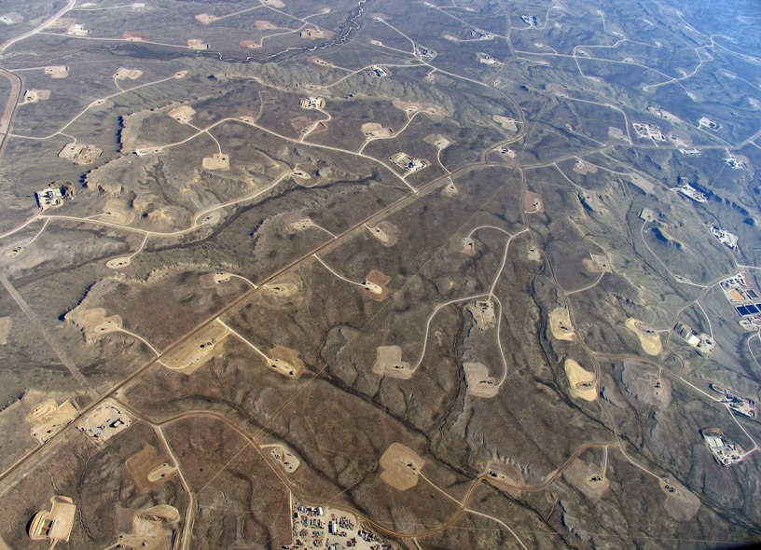

Fracking in Wyoming. Photo by EcoFlight, courtesy of SkyTruth

Often, wastewater is stored in large evaporation pits, which can off-gas volatile chemicals. Off-gassing is the evaporation of volatile chemicals at normal atmospheric pressure. In 2008, scientists recorded high levels of Volatile Organic Compounds (VOCs) from gas production operations in Colorado, and high levels of wintertime ozone pollution have been linked to oil and gas operations in Wyoming and Utah. (Guyathri Vaidyanathan, “Colo. Plan goes after haze tied to oil and gas operations,” E&E Reporter, 3/12/2012; Mark Jaffe, [“Like Wyoming, Utah finds high level of wintertime ozone pollution near oil, gas wells,”](http://www.denverpost.com/business/ci_20042330/) Denver Post, 2/26/2012)

The solid waste left over from evaporation pits and land application is treated as ordinary solid waste and exempt from many federal and state regulations, though it can contain toxic residue from the frack fluid. (Ian Urbina, [“Recycling of fracking wastewater is no cure-all,”](http://www.nytimes.com/2011/03/02/us/02gas.html?pagewanted=all) New York Times, 2/2/2011)  Drillers are permitted to apply fracking wastewater residues to roads for de-icing and dust suppression in states like Pennsylvania and New York, and allowed to [spray it into the air](http://www.dentonrc.com/local-news/special-projects/gas-well-drilling-headlines/20110331-practice-lays-waste-to-land.ece)over tracks of land used for agriculture in Texas.

**EPA’s Study of Hydraulic Fracturing Impacts on Groundwater**

In 2015, a Greenpeace investigation found that the shale industry had undue influence on EPA’s study of fracking’s impact on groundwater.

Read more from [Inside Climate](http://insideclimatenews.org/news/02032015/can-fracking-pollute-drinking-water-dont-ask-epa-hydraulic-fracturing-obama-chesapeake-energy) and [Desmog Blog](http://www.desmogblog.com/2015/03/02/internal-documents-reveal-extensive-industry-influence-over-epa-s-national-study-fracking" \t "_blank).

How Fracking Works

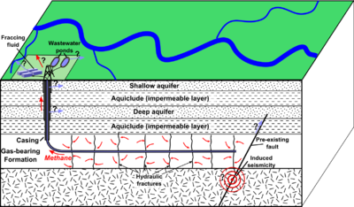

[[](javascript:swapDiv(246682,true,%20'block'))Show caption](javascript:swapDiv(246682,true,%20'block'))

Vertical well bores are drilled thousands of feet into the earth, through sediment layers, the water table, and shale rock formations in order to reach the oil and gas. The drilling is then angled horizontally, where a cement casing is installed and will serve as a conduit for the massive volume of water, fracking fluid, chemicals and sand needed to fracture the rock and shale. In some cases, prior to the injection of fluids, small explosives are used to open up the bedrock. The fractures allow the gas and oil to be removed from the formerly impervious rock formations.

Although fracking has technically been in existence for decades, the scale and type of drilling now taking place, deep fracking, is a new form of drilling and was first used in the Barnett shale of Texas in 1999.

Risks and Concerns of Fracking

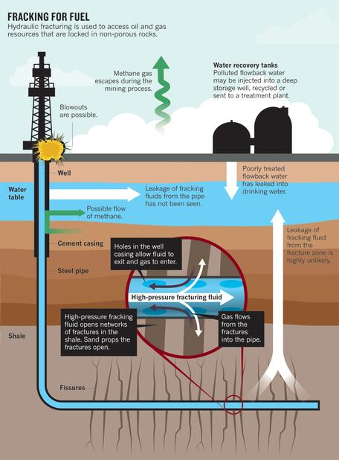

[[](javascript:swapDiv(246737,true,%20'block'))Show Caption](javascript:swapDiv(246737,true,%20'block'))

* Contamination of groundwater
* Methane pollution and its impact on climate change
* Air pollution impacts
* Exposure to toxic chemicals
* Blowouts due to gas explosion
* Waste disposal
* Large volume water use in water-deficient regions
* Fracking-induced earthquakes
* Workplace safety
* Infrastructure degradation

Source of Fracking Contamination

Due to the multitude of potential health and environmental impacts of hydrofracking source contamination can be complicated. The well location where drilling takes place is only one piece of the frack puzzle. Since each well can require up to 8 million gallons of water, and up to 40,000 gallons of chemicals, a well site may need up [to 2000 tanker truck trips](http://www.thenation.com/article/171504/fracking-our-food-supply), per frack. A well can be fracked up to 20 times.

Storage for the waste water can take place either on site, in an injection well, or in open air ponds in the surrounding areas. Transport of the waste poses a contamination risk outside the actual well location. Air pollution also extends beyond the immediate drilling site and transportation route, since a by-product of natural gas drilling is methane gas, one of the worst greenhouse gas pollutants contributing to climate change.

Impacts of Fracking

**Air Pollution**

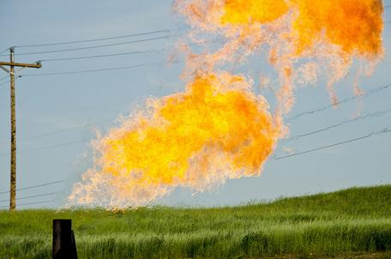

[[](javascript:swapDiv(207038,true,%20'block'))Show caption](javascript:swapDiv(207038,true,%20'block'))

Methane is a main component of natural gas and is 25 times more potent in trapping heat in the atmosphere than carbon dioxide. A recent study by the National Oceanic and Atmospheric Administration (NOAA) monitoring gas wells in Weld County, Colorado, estimated that 4 percent of the methane produced by these wells is escaping into the atmosphere. NOAA scientists found the Weld County gas wells to be equal to the carbon emissions of 1-3 million cars.

A number of other air contaminants are released through the various drilling procedures, including construction and operation of the well site, transport of the materials and equipment, and disposal of the waste. Some of the pollutants released by drilling include: benzene, toluene, xylene and ethyl benzene (BTEX), particulate matter and dust, ground level ozone, or smog, nitrogen oxides, carbon monoxide, formaldehyde and metals contained in diesel fuel combustion---with exposure to these pollutants known to cause short-term illness, cancer, organ damage, nervous system disorders and birth defects or even death .

The Associated press recently reported that [Wyoming's air quality near rural drilling sites is worse than Los Angeles'](http://www.nbcnews.com/id/41971686/ns/us_news-environment/%20%20%22#.UfAVj40e2So)--with Wyoming ozone levels recorded at 124 parts per billion compared to the worst air day of the year for Los Angeles, at 114 parts per billion. The Environmental Protection Agency's maximum healthy limit is 75 parts per billion.

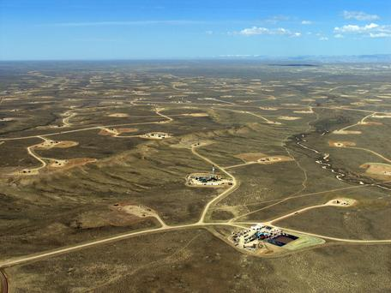

[[](javascript:swapDiv(225698,true,%20'block'))Show caption](javascript:swapDiv(225698,true,%20'block'))

A 2007 report prepared for the Western Governor's Association, that inventoried present and future nitrogen oxide and sulfur dioxide emissions from oil and gas drilling in the west, projects Montana to experience a [310% increase in nitrogen oxide pollution](https://web.archive.org/web/20150319063313/http:/www.ourpubliclands.org/files/upload/Air_Pollution_Report_RMCAA.pdf) (smog).

Crystalline silica, in the form of sand, can cause silicosis (an incurable but preventable lung disease) when inhaled by workers. Sand is a main ingredient used in the fracking process. The National Institute for Occupational Safety (NIOSH) [collected air samples from 11 fracking sites](http://blogs.cdc.gov/niosh-science-blog/2012/05/silica-fracking/) around the country. All 11 sites exceeded relevant occupational health criteria for exposure to respirable crystalline silica. In 31% of the samples, silica concentrations exceeded the NIOSH exposure limit by a factor of 10, which means that even if workers were wearing proper respiratory equipment, they would not be adequately protected.

**Water Pollution:**

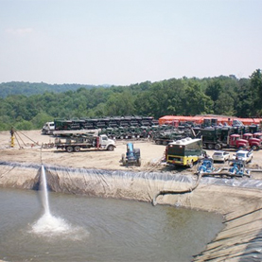

[[](javascript:swapDiv(246788,true,%20'block'))Show caption](javascript:swapDiv(246788,true,%20'block'))

Chemical additives are used in the drilling mud, slurries and fluids required for the fracking process. Each well produces millions of gallons of toxic fluid containing not only the added chemicals, but other naturally occurring radioactive material, liquid hydrocarbons, brine water and heavy metals. Fissures created by the fracking process can also create underground pathways for gases, chemicals and radioactive material.

The Environmental Protection Agency [(EPA)](https://www.epa.gov/sites/production/files/documents/PavillionWyomingFactSheet.pdf) and United States Geological Survey [(USGS)](http://pubs.usgs.gov/ds/718/DS718_508.pdf) have recently confirmed what residents of Pavillion, Wyoming had been claiming--that hydrofracking had contaminated their groundwater.

The Environmental Protection Agency (EPA) initially under an [emergency administrative order](https://yosemite.epa.gov/oa/rhc/epaadmin.nsf/Filings/3973BBFC0F02C25F85257B89001BCB0D/$File/SDWA0820130035%20AO.pdf) forced three oil production companies operating on the Fort Peck Reservation, to reimburse the city of Poplar, MT for water infrastructure expenditures incurred as a result of drilling contamination. The oil companies appealed the EPA order, but were forced to rectify their violations by a federal judge.

Another scenario for contamination to occur is by faulty design or construction of the cement well casings--something that happened in the BP Gulf blowout disaster. Storage of the waste water is currently under the regulatory jurisdiction of states, many of whom have weak to nonexistent policies protecting the environment.

**Soil and Oil Spill Contamination:**

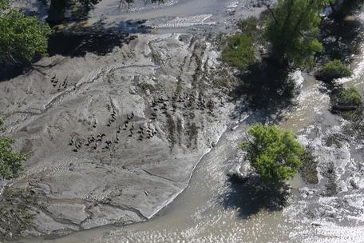

Resident Canada geese inhabit impacted portion of Yellowstone River July 9, 2011.[[reuse info]](https://serc.carleton.edu/details/images/57247.html)

According to journalists at [Pro Publica,](http://www.propublica.org/article/the-other-fracking-north-dakotas-oil-boom-brings-damage-along-with-prosperi) oil companies reported over 1,000 oil spills in North Dakota, 2011, with many more going unreported, state officials admit. The Associated Press also recently reported that the amount of chemically tainted soil from drilling waste increased nearly 5,100 percent over the past decade, to more than 512,000 tons last year. Steve Tillotson, assistant director of the North Dakota Health Department's waste management division, told reporters that trucks are hauling oilfield waste to facilities "24 hours a day, seven days a week."

An [ExxonMobil pipeline rupture spilled 42,000 gallons of oil into the Yellowstone River](http://www.nydailynews.com/news/national/exxon-oil-spill-montana-yellowstone-river-prompts-evacuations-article-1.155517), near Billings, MT. In the aftermath of the spill, ExxonMobil has disclosed that the [pipeline has been transporting tar sands oil](http://www.reuters.com/article/2011/07/15/us-oil-spill-montana-idUSTRE76E6WN20110715) from Alberta, Canada, which is a low grade, more toxic and corrosive type of oil. Regulators had not been informed that the pipeline was carrying tar sands oil and the disclosure was a result of the spill. Tar sands oil was not in the pipeline at the time of the spill, though regulators are investigating whether or not it played a role in causing the pipeline to corrode.

**Earthquakes**

Earthquakes constitute another problem associated with deep-well oil and gas drilling. Scientists refer to the earthquakes caused by the injection of fracking wastewater underground as ["induced seismic events."](http://i2.cdn.turner.com/cnn/2012/images/06/15/induced.seismicity.prepublication.pdf) Although most of the earthquakes are small in magnitude (the strongest measured 5.2), their relationship with the storage of millions of gallons of toxic wastewater does little to ease the fears over fossil energy's long list of externalities.

Health Effects of Fracking:

A 2011 article in the journal, *Human and Ecological Risk Assessment*, examined the [potential health impacts of oil and gas drilling](https://www.biologicaldiversity.org/campaigns/fracking/pdfs/Colborn_2011_Natural_Gas_from_a_public_health_perspective.pdf) in relation to the chemicals used during drilling, fracking, processing,and delivery of natural gas. The paper compiled a list of 632 chemicals (an incomplete list due to trade secrecy exemptions) identified from drilling operations throughout the U.S. Their research found that 75% of the chemicals could affect the skin, eyes,and other sensory organs, and the respiratory and gastrointestinal systems. Approximately 40–50% could affect the brain/nervous system, immune and cardiovascular systems, and the kidneys; 37% could affect the endocrine system; and 25% could cause cancer and mutations.

Health impacts from fracking are only now being examined by health experts, since such large-scale drilling is a recent phenomenon. Exposure to toxic chemicals even at low levels can cause tremendous harm to humans; the endocrine system is sensitive to chemical exposures measuring in parts-per-billions, or less. Nevertheless, many of the health risks from the toxins used during the fracking process do not express themselves immediately, and require studies looking into long-term health effects.

Despite the complexities of the on-site mixtures of chemicals and their specific contributions to health and environmental problems involved in fracking--conventional drilling practices are more old school and do have known health consequences. Researchers at the [Colorado School of Public Health, University of Colorado](http://www.ucdenver.edu/academics/colleges/PublicHealth/Pages/default.aspx), analyzed existing research of exposure to conventional petroleum hydrocarbons in occupational settings, and residences near refineries, in conjunction with known pollutants associated with fracking (nonconventional), in order to assess health risks to those residents living near fracking operations. Their basic conclusions were: the closer you live to drilling operations, the greater your health risk. Sounds obvious, but if you were to sue an oil company for the suspected killing a loved one via cancer, you would need a little more legal ammunition than "it just makes common sense" against an army of corporate lawyers.

Although the Centers for Disease Control and Prevention (CDC) has yet to investigate the potential impacts of fracking, the director of CDC's National Center for Environmental Health and the agency for Toxic Substances and Disease Registry, Christopher J. Portier, PhD, has called for health studies to be published.

A 2012 paper was published in the journal, *Environmental Health Perspectives*, examining the composition of state and federal advisory committees tasked to consider the potential environmental and health effects of fracking in the Marcellus shale region. The researchers found that there was [not one health expert](http://www.ncbi.nlm.nih.gov/pmc/articles/PMC3339470/) among the 52 people comprising the various state and federal commissions and boards, even though public health was specified in the executive orders creating the committees.

Prevention or Mitigation

While many state agencies function more as facilitators of fossil energy development than regulators, federal guardians of public health are also vulnerable to 'getting into bed' with big business, literally. One need only recall the former federal agency in charge of collecting oil and gas royalties on public lands, the Minerals Management Service. Employees from the Bush administration working for that regulatory agency were [caught using cocaine and marijuana, and had sexual relations with oil and gas company representatives.](http://www.nytimes.com/2008/09/11/washington/11royalty.html?pagewanted=all)

Many people concerned by nonconventional oil and gas drilling would prefer the US adopt the so-called precautionary principle, which places the burden of proof on industries implementing new technologies and introducing new chemicals into our neighborhoods and environment. If your actions do not poison the water, accelerate climate change, cause cancer to those living near drilling and refineries, etc.—prove it. Current policy inverts such logic, instead forcing the victim (or their surviving relatives) to get into a legal fight with some of the richest and most politically powerful companies.

At a minimum, more stringent regulations should be passed at the national level, including repeal of oil and gas exemptions from the Safe Drinking Water Act. Violators of clean water and air laws should be prohibited from obtaining federal and state land drilling leases. Flaring of natural gas should be more strictly regulated. If a carbon tax were to be passed, energy companies would no longer get away with passing their so-called externalities (pollution) on to the community, tax payer, or environment.

Another approach would be the adoption of a legitimate national energy policy that is comprehensive in scope and science-based, as opposed to the current singular focus on short-term profits. Something more in line with what is occurring in Germany--where they have increased clean energy use from 6% in 2002, to 26% in 2012. A clean energy policy propelled by sophisticated technologies that require skilled workers could replace the third world fossil energy model en vogue these days. The spector of climate change makes the acclerated pursuit of carbon based fuel an irrational policy predicted to be far more expensive than the initial costs required to switch to clean energy technologies.

Recommended Readings

**Bamberger, M., Oswald, R. (2012). [link** **https://web.archive.org/web/20150414105739/http://www.psehealthyenergy.org/data/Bamberger\_Oswald\_NS22\_in\_press.pdf 'Impacts of Gas Drilling on Animal and Human Health.']*New Solutions: A Journal of Environmental and Occupational Health*, 22(1): 51-77.**

The researchers conducted interviews with animal owners in six states--Colorado, Louisiana, New York, Ohio, Pennsylvania, and Texas--affected by gas drilling. They also interviewed the owners' veterinarians, and examined the results of water, soil, and air testing as well as the results of laboratory tests on affected animals and their owners. The study highlights the possible links between gas drilling and negative health effects, along with the difficulties associated with conducting careful studies of such a link.

**Colborn T, Kwiatkowski C, Schultz K, Bachran M. 2012.**[**Natural Gas Operations from a Public Health Perspective**](http://www.tandfonline.com/doi/abs/10.1080/10807039.2011.605662)**. *Human and Ecological Risk Assessment: an International Journal* 17(5):1039-1056.**

The authors examined the chemicals known to be used in natural gas fracking procedures. Researchers were able to compile a list of 632 chemicals, though this list is incomplete due to trade secret ememptions given to the energy companies by Congressional allies. Many of the chemicals are toxic and represent the 'bad boys' of health concerns--causing everthything from skin and eye irritation to cancer and mutuations. They also highlight the "side effect" of air pollution and the resulting irriversable damage to lung tissue, along with damage to vegetation in the surrounding area.

**Finewood, M. H. and Stroup, L. J. (2012), [link** **https://onlinelibrary.wiley.com/doi/full/10.1111/j.1936-704X.2012.03104.x'Fracking and the Neoliberalization of the Hydro-Social Cycle in Pennsylvania's Marcellus Shale']. Journal of Contemporary Water Research & Education, 147: 72–79. doi: 10.1111/j.1936-704X.2012.03104.x**

This article paper discusses how institutional forces from the energy industry, the media, and government obfuscate the impacts of fracking on communities and the environment. The narrative framing of natural gas as a 'green energy', or the fetishism of 'national energy independence' legitimizes and normalizes the harm to local water resources and local communities. Impacts to local health and ecology are pitted against the national agenda to retain dependence on fossil energy.

**Horton, S. Disposal of hydrofracking waste fluid by injection into subsurface aquifers triggers earthquake swarm in central Arkansas with potential for damaging earthquake  
*Seismological Research Letters*(April 2012), 83(2):250-260*Environ Health Perspect*120(4).**[**http://dx.doi.org/10.1289/ehp.1104594**](http://dx.doi.org/10.1289/ehp.1104594)

This paper discusses waste fluid induced earthquakes related to fracking in Arkansas. The authors propose careful geologic study of those areas where wastewater injection occurs, since it is believed by geologists that the millions of gallons of fluids forced underground at high pressure can trigger earthquakes.

**Howarth RW et al (2011). Methane and greenhouse-gas footprint of natural gas from shale formations. *Climatic Change Letters*. DOI 10.1007/s10584-011-0061-5**

The greenhouse gas footprint is now known to have been significantly underestimated. This research assesses the role of methane being released by natural gas wells and its impact on climate change. Although natural gas was thought to be a cleaner form of energy than coal and oil, its relationship with methane actually makes it dirtier than the other two, in regards to their impact on climate change.

**McKenzie L, Witter RZ, Newman LS, Adgate JL, 2012,**[**Human Health Risk Assessment of Air Emissions from Development of Unconventional Natural Gas Resources**](http://www.ncbi.nlm.nih.gov/pubmed/22444058)**, *Science of the Total Environment,*424:79-87.**

Researchers from the Colorado School of Public Health used EPA guidance to estimate chronic and subchronic non-cancer hazard indices and cancer risks from exposure to hydrocarbons for two populations: (1) residents living > ½ mile from wells and (2) residents living ≤ ½ mile from wells. Risks were higher for those living less than a 1/2 mile from wells than those living further from drilling sites.

**Stephen G. Osborn, Avner Vengosh, Nathaniel R. Warner, and Robert B. Jackson Methane contamination of drinking water accompanying gas-well drilling and hydraulic fracturing PNAS 2011 108: 8172-8176.**

Scientists found methane contamination of drinking water associated with shale-gas extraction. Average and maximum methane concentrations in drinking-water wells increased with proximity to the nearest gas well. Researchers also found a potential explosion hazard with the related concentrations of methane.